Software Testing Assignment

Module–1(Fundamental)

**Que 1.) What is SDLC ?**

**Ans. :** SDLC stands for software development life cycle. It’s contained 6 phases for this process. Which are Requirement and information gathering, Analysis, Design, Implement, Testing and Maintenance.

**Que 2.) What is software testing?**

**Ans. :** Software testing is a process used to identify correctness, completeness and qualify of developed computer software.

**Que 3.) What is agile methodology?**

**Ans. :** Agile methodology is combination of iterative and increment model. It is suitable for medium or large project and project-based company. It’s required teamwork and training. It’s easy for development phase. It does not attempt to start with all specification requirements. We can add new requirements and functionality in future, that’s why it’s difficult to maintain and manage risk and extensibility. So, it’s not suitable for complex projects. And this model is for project-based company , so if agile leader or agile pm is leave then project will impossible to manage and maintain. In this we can switch the phase from one to another, that’s why it’s easy to develop and testing.

**Que 4.) What is SRS?**

**Ans. :** SRS stands for Software Requirement Specification. It is containing set of standards, description and rules that how the system should behave.

Basically, there are 3 types of requirements :

i.) Customer Requirements :

These are requirements which customer required and needs. They ask each and every thing about the project like what should be development , how can it design and architect, what are requirements, in which environment projects can run , performance , quality , life cycle and etc.

ii.) Functional Requirements :

It’s contained technical requirements, design like the software should have all this functionality which client was demanded.

iii.) Non-functional Requirements :

It’s contained set of standard and rules that how that software should behave. And it’s not contained technical part, its defined criteria where the system should be work. Its all about the performance and quality of software.

**Que 5.) What is oops?**

**Ans. :** OOP stands for Object Oriented Programming. Oops is identify object and communicate with each other by sending message. Message are sent by function or method which is specify task to what to do with that method or function. And all methods and class are under object and all object are under class. So, this is oops.

**Que 6.) Write Basic Concepts of oops.**

**Ans. :** Oops has 6 features like Object, Class, Inheritance, Polymorphism( method overloading and method overriding.), Encapsulation and Abstraction.

**Que 7.) What is object?**

**Ans. :** Any thing which has specific behaviour it’s called object

**Que 8.) What is class?**

**Ans. :** Collection of objects or which contains all data member ,it’s called class.

**Que 9.) What is encapsulation?**

**Ans. :** Encapsulation is wrapped up data (like methods, functions or properties) of an object for hiding purpose. It’s provided a shield to hidden data. And not everyone can access it. So only authorize methods can access their objects.

**Que 10.) What is inheritance?**

**Ans. :** Inheritance is that one class can inherits from another class. It’s like parent-child or super-sub class. That child can access parent property or sub class can inherits super class property. Child can access all property of parent class but parent class can not access child class’s all property. And there are many types of inheritance like single inheritance, multiple inheritance, multilevel inheritance, hierarchy inheritance and etc.

**Que 11.) What is polymorphism?**

**Ans. :** Polymorphism means “having many forms”. You can operate method or print same message in different ways. The ability to change form is known as polymorphism. There are 2 types of polymorphism; one is method overriding and second one is method overloading.

**Que 12.) Draw Use case on Online book shopping.**

**Ans. :**

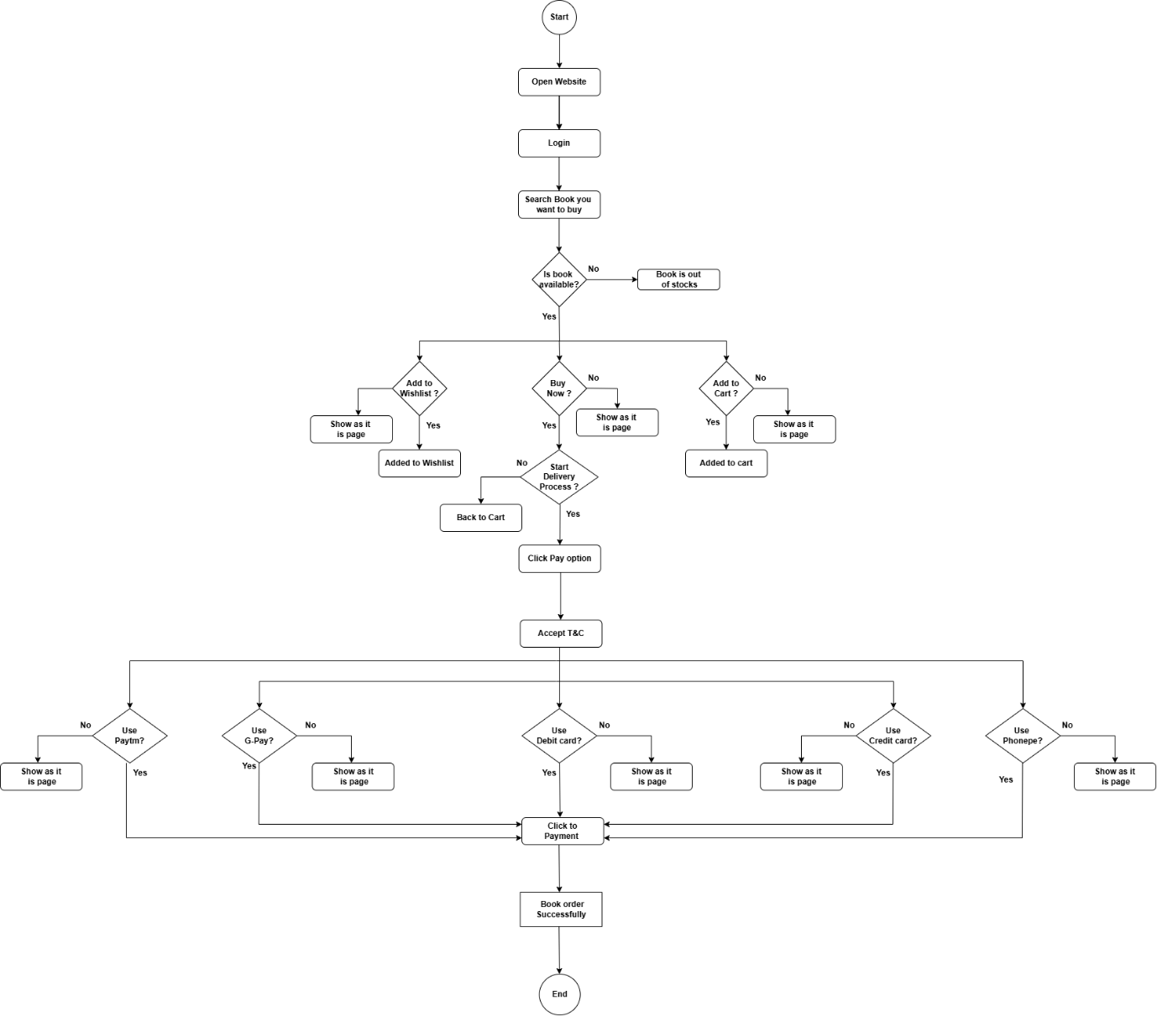

**Que 13.) Draw Use case on online bill payment system (Paytm).**

**Ans. :**

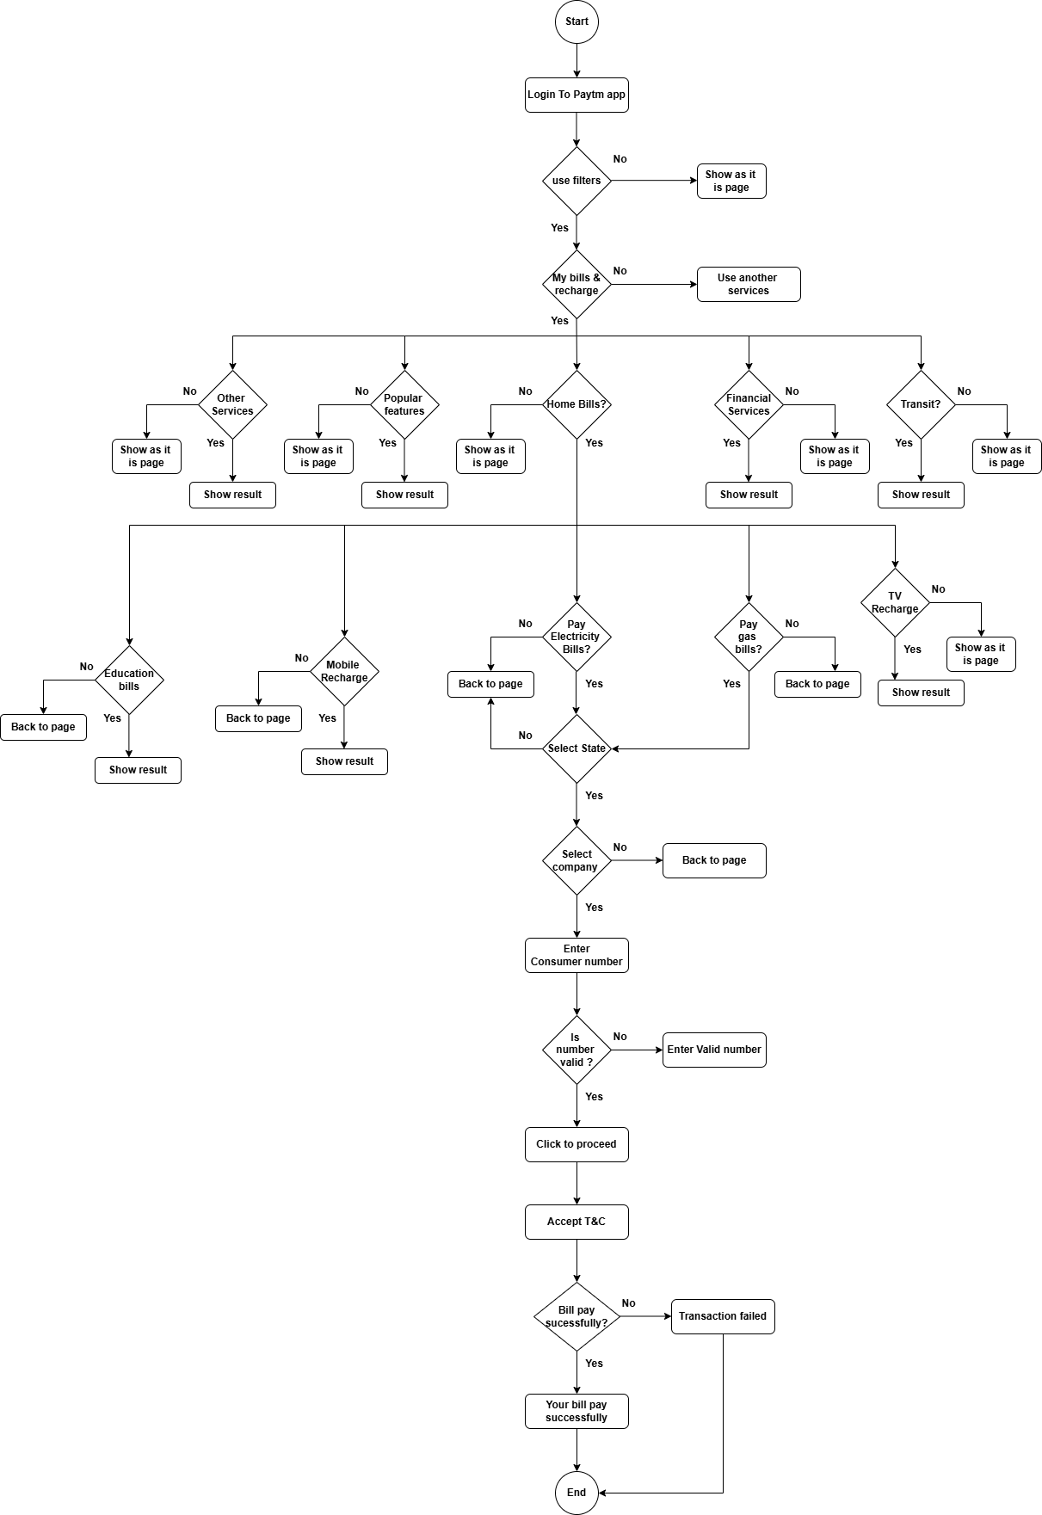

**Que 14.) Write SDLC phases with basic introduction.**

**Ans. :** It’s contained 6 phases for this process. Which are Requirement and information gathering, Analysis, Design, Implement, Testing and Maintenance.

1.) Requirement and information Gathering : this phase is for what are requirements of customer/ client , all the information of requirements are discuss here.

It’s having 2 functionalities : i.) Functional

ii.) Non-functional

Functional Requirements are which ,where those functionalities stay permeant to website or web application and which are possible to make and implement in our source code.

Where Non-functional Requirements are which are temporary used in our code, it’s not permeant, its work for short time of period and can’t possible to apply for long time.

And we can describe in 3 formats -> 1.) Diagram 2.) Table 3.) verbal format

2.) Analysis : All the information is discussed in 1st phase, it’s analyses in this phase that how to apply and where to place ,which platform can we use, what we can do , and all WH questions are required here , so we can follow up the plan. Simply it’s solved the problem of client requirements that how can we implements all finish up.

3.) Design : this phase is for designer which can be UX/UI designer, web designer or software designer , they’ll design according to client requirements and needs. They follow up the plan which already made in analysis phase. So needed architecture and design are made here.

4.) Implement : It’s for developer ,they make app or website according to our plan and architecture or design. The app or website should be made of client requirements and guidelines , otherwise we can’t fulfil customer needs and trust. So, it’s very important to put all functionality which are discuss in design phase.

5.) Testing : This is our job. Testing can be done by Software tester, QA/QC analyst, and Manual tester. We have to test that all the functionality are work properly or not, any bugs or error pop when user click some buttons or any other field. Testing is much important because it’s made user-friendly web application or website. And make bug free software.

Testing has many types like : i.) Regression testing

ii.) Application testing

iii.) Mobile testing

iv.) Stress testing

v.) Unit testing

6.) Maintenance : last but not least, maintenance is also important to keep our software or website user-friendly, once we created any website/ app ; our job is not done, we keep maintain the website to manage website traffic, database or functionality. If we want to add new features then it’s required to maintain the performance as before the implements.

It has 3 types :

i.) Corrective Maintenance : It’s used to maintain our current functionality maintain properly and without any bugs or error. Its identify and repairing defects if any error generate.

ii.) Adaptive Maintenance : It’s when we want to add new platform for website/ web application. The old platforms are kept remain.

iii.) Perfective Maintenance : It’s when we want to add new features to make our app/ website completeness or perfect. So, it’s our responsibility to make every function work properly even after add new features.

**Que 15.) Explain Phases of the waterfall model.**

**Ans. :** Waterfall model is for small projects. It’s for those projects which are not change their requirements. Waterfall model behaviour is conservative. You can not change requirements after the project is start that’s why it is risky for complex project or long project. And you can not check progress of your project. You can not jump to other phases while one phase is not completed. But it is conservative; it is easy to manage because you know that these are the final requirements. You don’t have to think about other complexity. It is usable for those who have set specific requirements and in future they don’t want to change. It is oldest model and suitable for most of the company.

It has 6 phases :

i.) Requirements collection

ii.) Analysis

iii.) Design

iv.) Implementation

v.) Testing

vi.) Maintenance

i.) Requirement collection : First of all , client and the company discuss all requirements which are needed for this project and they collect all information about these requirements.

ii.) Analysis : After that analysis team has analyse all requirements and make report on how the all requirements can implemented and what are the requirements have high priorities and how can it be done. What can we do if this problem occurs and how can we overcome of it. All the talk related requirements and their implementation are discussed here.

iii.) Design : Now, we are known about how can we do, so designer is designing the structure of software so we can easily implement the code.

iv.) Implementation : Once, design is ready , the developer can start coding and developed a software according to the needs.

v.) Testing : Once, the software done by developer, tester is testing the website or application and finds defect if any occurs.

vi.) Maintenance : And final phase is maintenance, when the software is tested, our work is not done, we have regularly maintained the software for the best performance.

In these phases, we can not move one to another phase or in reverse phase, because it’s not possible to go reverse because of we already fix our requirements and if we have to go then money, time and all work are consider as failure.

**Que 16.) Write phases of spiral model.**

**Ans. :** Spiral model has 4 phases.

i.) Planning

ii.) Risk analysis

iii.) Engineering

iv.) Customer Evaluation

i.) Planning :

Planning phase is for make a plan about the project. What are the initial requirements that are discuss in this phase.

ii.) Risk Analysis :

In this phase team has recognize that any risk will occurs in the future or not , or any budget issue will come or not, this line is for go, no-go decision that we have to go in next phase or not. All the risk are analysis in this phase.

iii.) Engineering :

it is a phase of development or implementation. Developers are developing the software according to the design structure or architecture.

iv.) Customer Evaluation :

In this phase, company is reviewing the customer feedback and then decide to what are important to implement in exist features and what features are not required in the software.

This cycle is running until the product is not finished. We can add new requirements and implement that functionality continuously.

**Que. 17) Write agile manifesto principles.**

**Ans. :** Agile methodology is combination of iterative and increment model. It is suitable for medium or large project and project-based company. It’s required teamwork and training. It’s easy for development phase. It does not attempt to start with all specification requirements. We can add new requirements and functionality in future, that’s why it’s difficult to maintain and manage risk and extensibility. So, it’s not suitable for complex projects. And this model is for project-based company , so if agile leader or agile pm is leave then project will impossible to manage and maintain. In this we can switch the phase from one to another, that’s why it’s easy to develop and testing. So, we can implement in unit testing and it’s typically done by two-to-three weeks. And in every two-to-three week stakeholders can see working product. Agile methodology is dividend into smaller parts so it’s easy to manage and testing for teams.

**Que 18.) Explain working methodology of agile model and also write pros and cons.**

**Ans. :** Agile methodology works for medium or large products and its divides their parts into pieces so its easy to manage and testing. But it is complex to maintaining whole project duration without Agile Leader or Agile PM.

Here are some pros and cons, which are given below.

Pros :

Promotes teamwork and training.

It’s suitable for fixed and changing requirement.

It’s divided in small parts so, easy to manage.

Functionality can develop fast and easily.

Delivers products early to stakeholders.

Little or no planning required.

Give flexibility and scalability to developer.

It is realistic approach for software development.

Less requirement needed.

Mostly used by product-based company.

Cons :

It is not suitable for complex dependencies.

There is more risk to maintain to whole project.

It is difficult to manage project if Agile Leader or Agile PM is in leave, without them it’s impossible to manage because they have whole project information .

It is difficult to meet deadlines, time manage and scope which we decided earlier to deliver to stakeholders.

It is not suitable for small projects.

If we transfer in technology to new members, then it’s difficult to manage because of lack documentation or information.

It is depended on customer interaction, so if customer/client is not clear then whole project can go in wrong direction.

So, these are pros and cons which are described above.

**Que 19.) Draw use case on Online shopping product using COD.**

**Ans. :**

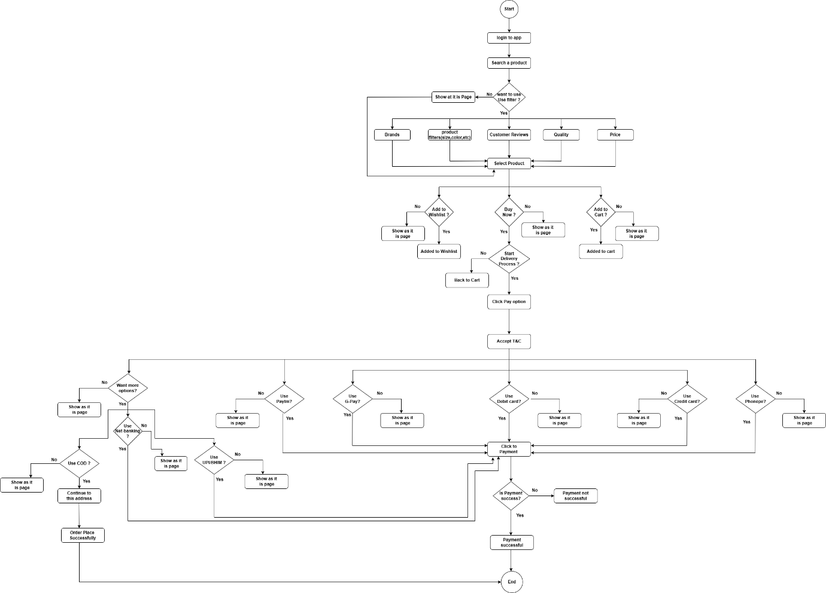

**Que 20.) Draw use case on Online shopping product using payment gateway.**

**Ans. :**

